QUESTION 14
Title
SystemC Model for Simulating a Simple Embedded Controller and Timing Behavior Analysis
Question: Develop a SystemC model simulating a simple embedded controller and analyze timing behavior.
1. Aim
To design and simulate a simple embedded controller using SystemC. The controller reads sensor values, compares them with a predefined threshold, controls an actuator, and analyzes the timing behavior of the system.
2. Objective
- To understand SystemC modeling.
- To simulate an embedded controller.
- To study timing behavior using simulation time.
- To control an actuator based on sensor values.
- To demonstrate real-time execution.
3. Algorithm
- Start the simulation.
- Generate a sensor value.
- Compare the value with the threshold (50).
- If the value is greater than 50, turn the actuator ON.
- Otherwise, turn the actuator OFF.
- Wait for 10 ns.
- Repeat the process.
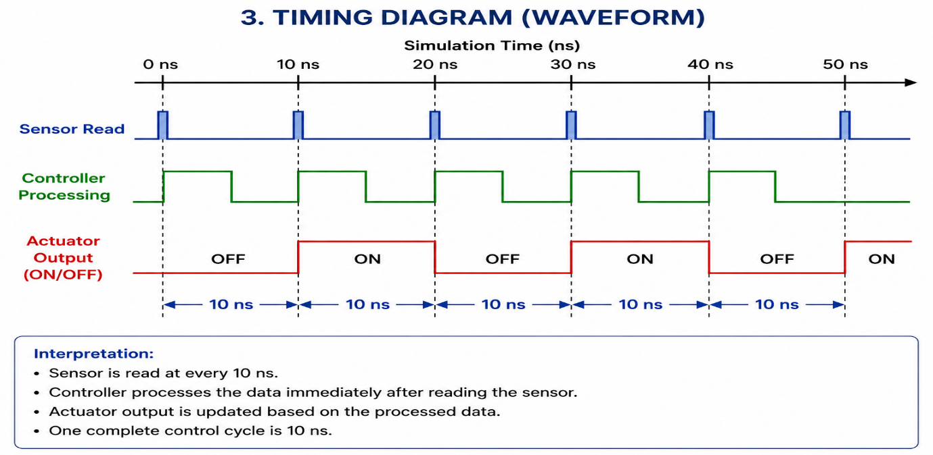
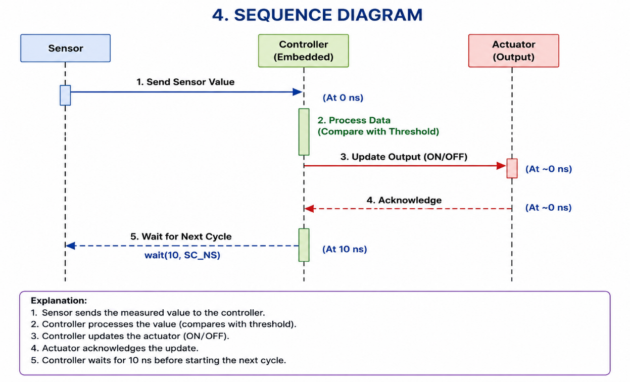
4. Program
#include <systemc.h>
#include <cstdlib>
SC_MODULE(EmbeddedController)
{
void controller()
{
int sensor;
while (true)
{
// Generate a random sensor value (0-99)
sensor = rand() % 100;
cout << "Time: " << sc_time_stamp()
<< " | Sensor Value: " << sensor;
if (sensor > 50)
cout << " --> Actuator ON";
else
cout << " --> Actuator OFF";
cout << endl;
// Wait for 10 nanoseconds
wait(10, SC_NS);
}
}
SC_CTOR(EmbeddedController)
{ SC_THREAD(controller); } };
int sc_main(int argc, char* argv[])
{ EmbeddedController controller("Controller");
// Run simulation for 100 ns
sc_start(100, SC_NS);
return 0;}
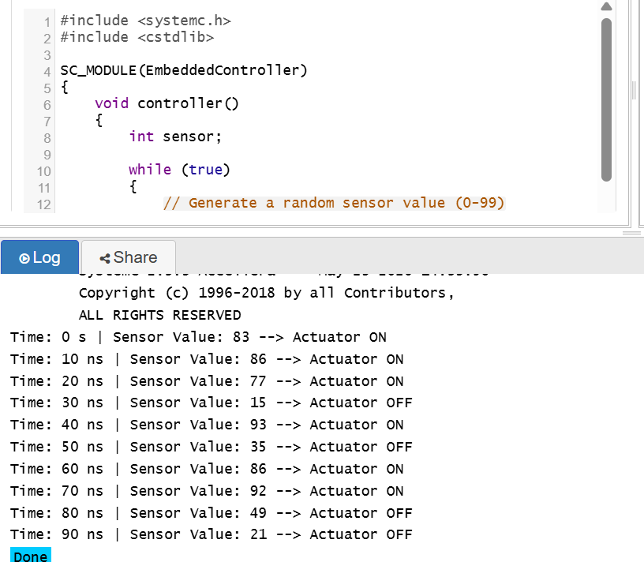

Result
The SystemC controller successfully simulated sensor monitoring and actuator control. Timing analysis showed deterministic execution with a 10 ns interval.

QUESTION 15
Title
SystemC Model for a Multi-Threaded Embedded System Using Synchronization
Question: Implement a SystemC model for a multi-threaded embedded system and evaluate synchronization techniques.
1. Aim
To implement a multi-threaded embedded system using SystemC and synchronize multiple processes using an event mechanism.
2. Objective
- To create multiple SystemC threads.
- To exchange data between threads.
- To synchronize processes using sc_event.
- To study concurrent execution.
- To analyze synchronization techniques.
3. Algorithm
- Start simulation.
- Create Sensor Thread.
- Generate sensor data.
- Notify the Controller Thread using sc_event.
- Controller waits for notification.
- Controller processes sensor data.
- Wait for the next sensor update.
- Repeat until simulation ends.
Synchronisation Techniques used :
Technique | SystemC Function | Purpose
Event Synchronization | sc_event | Creates an event for thread communication
Event Notification | notify() | Signals that new data is available
Event Waiting | wait() | Suspends the controller until the event occurs
Shared Data Communication | Shared variable (sensor) | Transfers data between the threads

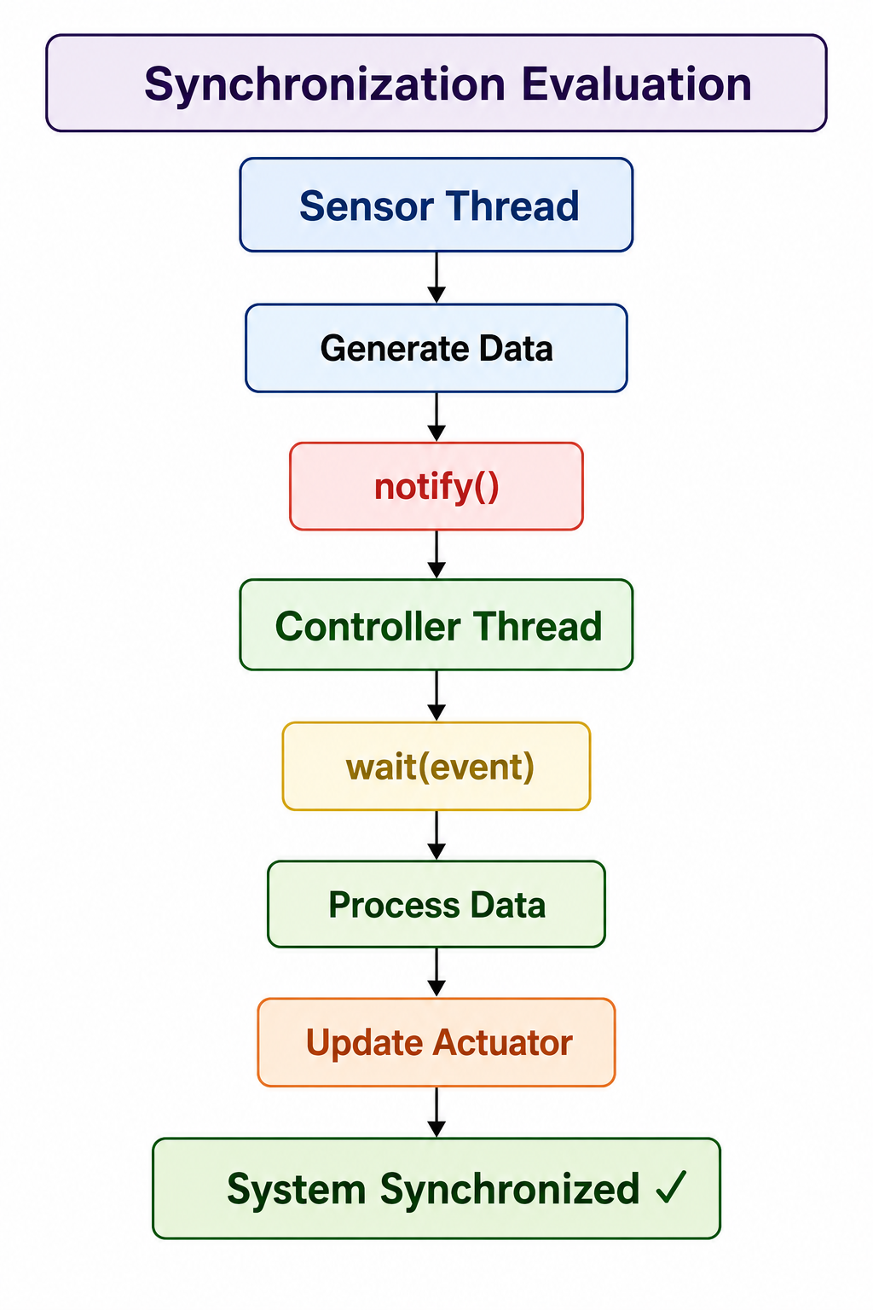
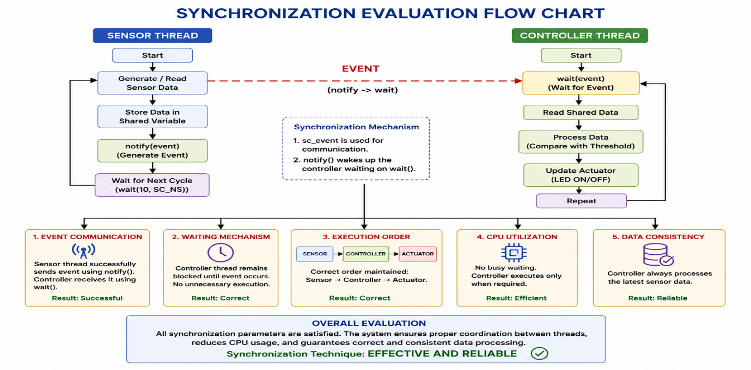
4. Program
#include <systemc.h>
#include <cstdlib>
SC_MODULE(MultiThreadSystem)
{
sc_event data_ready;
int sensor;
// Thread 1 : Sensor
void sensor_thread()
{
while (true)
{
sensor = rand() % 100;
cout << "Time: " << sc_time_stamp()
<< " | Sensor Value = "
<< sensor << endl;
// Notify controller thread
data_ready.notify();
wait(10, SC_NS);
}
}
// Thread 2 : Controller
void controller_thread()
{
while (true)
{
wait(data_ready);
cout << "Time: " << sc_time_stamp();
if(sensor > 50)
cout << " --> Motor ON";
else
cout << " --> Motor OFF";
cout << endl;
}
}
SC_CTOR(MultiThreadSystem)
{
SC_THREAD(sensor_thread);
SC_THREAD(controller_thread);
}
};
int sc_main(int argc, char *argv[])
{
MultiThreadSystem obj("EmbeddedSystem");
sc_start(100, SC_NS);
return 0;
}
Result
The multi-threaded SystemC model successfully demonstrated synchronized communication between sensor and controller threads using sc_event, ensuring reliable and efficient execution.
